700106 / 700120 Lab Book
Vulkan Exercises

Exercise 1: PREPARING FOR TANGENT SPACE
Solution & Reflection: I began by modifying the C++ Vertex struct to include glm::vec3 tangent and glm::vec3 binormal attributes, as shown in the first code screenshot. Following this, I updated the VkVertexInputAttributeDescription entries to account for these two new vec3 attributes, adjusting the binding locations and offsets so Vulkan can correctly read the new data structure from the vertex buffer. Finally, I updated the hard-coded Quad_vertices data (second screenshot) to include specific tangent ({1.0f, 0.0f, 0.0f}) and binormal ({0.0f, 1.0f, 0.0f}) vectors for each vertex, as suggested by the lab for a simple quad.

Reflection: This task was a key foundational step. It made it clear how the TangentBinormal-Normal (TBN) coordinate system is constructed from per-vertex data. Manually adding these vectors for a simple quad was easy, but it highlighted the complexity of generating them for arbitrary meshes. I now understand that these vectors are essential for creating a local coordinate system on the model's surface, which is necessary to correctly orient the normal map

Question: My screenshots show a GenerateTangents function that automatically calculates tangents and binormals based on vertex positions and UV deltas. How does this automatic, code-based calculation compare to using TBN vectors that are pre-calculated and exported directly from a 3D modeling program? Is one method generally preferred for accuracy, especially on models with complex UV seams?
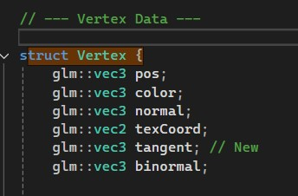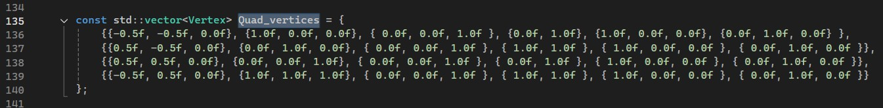

Exercise 2: NORMAL MAPPING IMPLEMENTATION
Solution: First, I implemented a GenerateTangents C++ function (visible in the screenshots) to automatically calculate the tangent and binormal vectors for the model's vertices, rather than hard-coding them. In the vertex shader (shader.vert), I added new in variables for inTangent and inBinormal. I used these, along with the inNormal, to build the TBN matrix. I then used this matrix to transform the world-space light position, view position, and fragment position into tangent space, passing them as out variables (fragLightPos_tangent, fragViewPos_tangent, etc.) to the fragment shader .
In the fragment shader (shader.frag), I added a new uniform sampler2D normalSampler at binding=2. I sampled this normal map and "unpacked" the resulting vector from its [0,1] texture-color range to the [-1,1] normalized vector range using the normalize(N * 2.0 - 1.0) formula. Finally, I performed all lighting calculations (ambient, diffuse, specular) entirely in tangent space, using this new sampled normal N and the interpolated tangent-space vectors. The final screenshot shows the rendered cube with a convincing, bumpy stone appearance.
Reflection: This exercise was a major step. It was insightful to see the lighting calculations move entirely into tangent space. It finally "clicked" why tangent space is so useful: the normal map always stores normals relative to a "flat" surface (where Z is "up"), and by transforming the light and view vectors into this same space, the lighting logic becomes universal and decoupled from the model's world-space orientation.

Question: In my vertex shader, I transform the light and view positions to tangent space and pass them to the fragment shader, where the L and V vectors are calculated after interpolation. Is this approach (interpolating positions) more or less accurate/performant than calculating the L and V vectors in world-space first (in the vertex shader) and then transforming those vectors into tangent space before passing them?
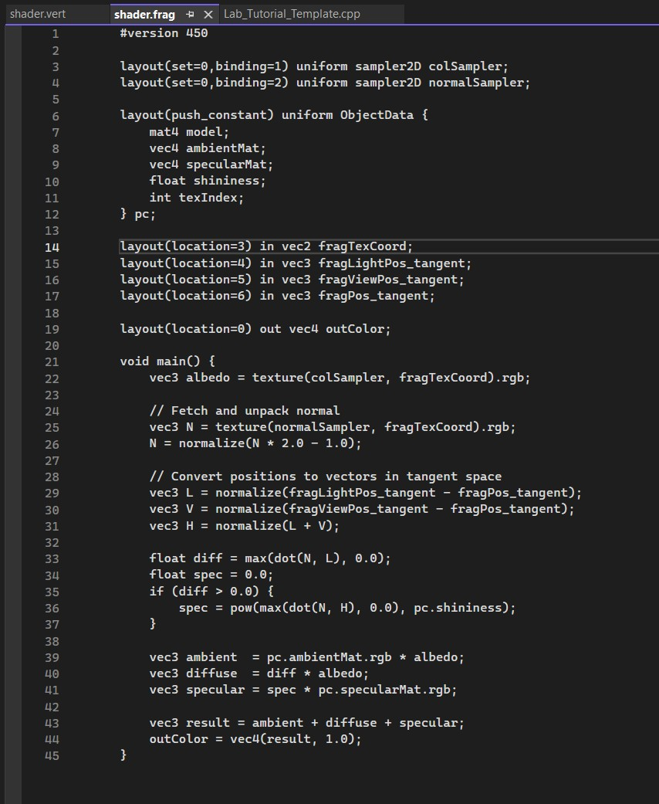

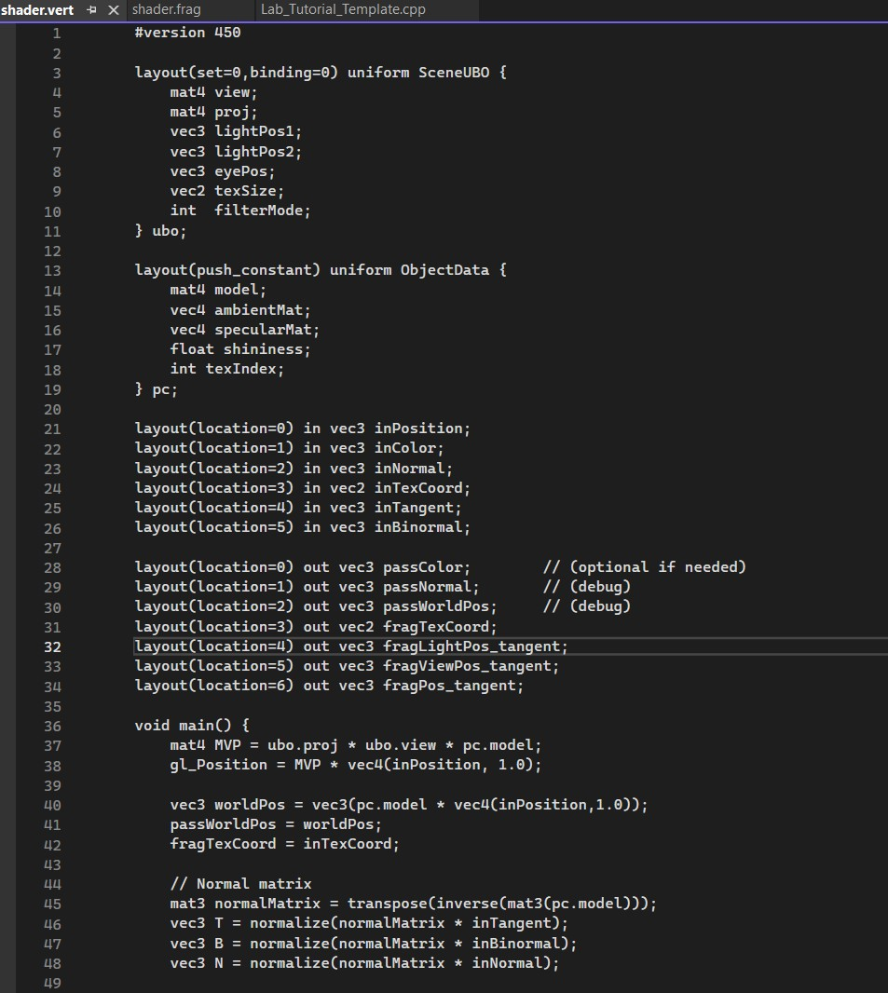

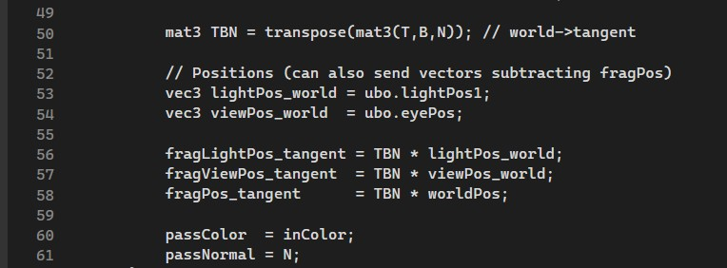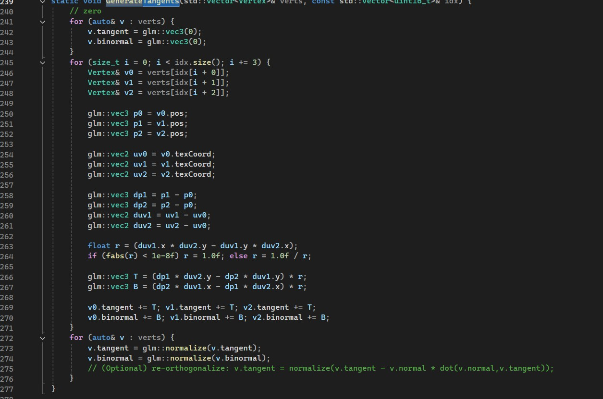
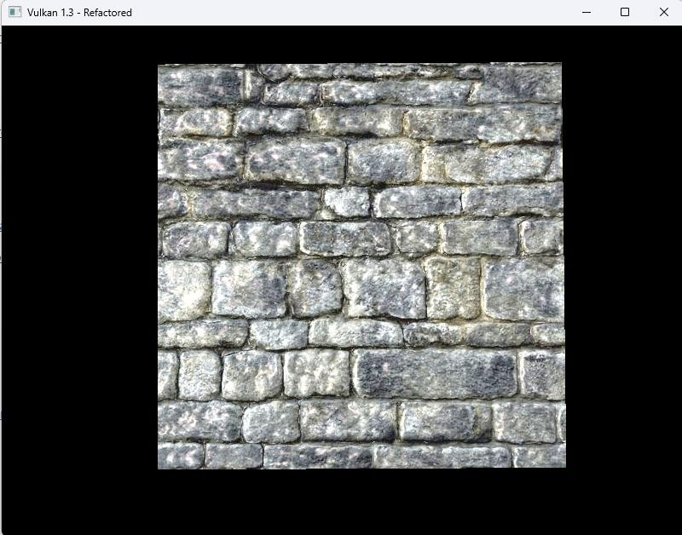
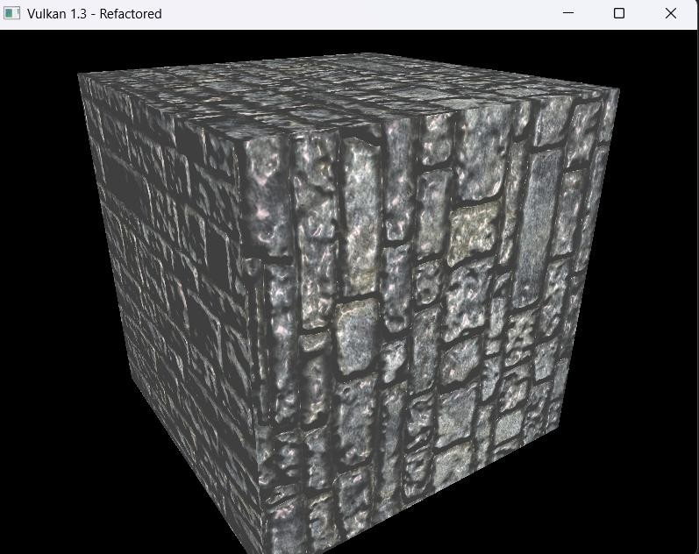
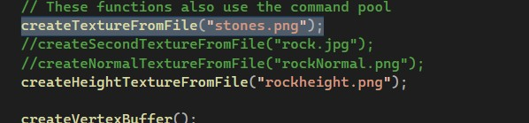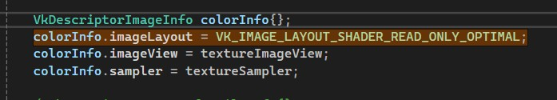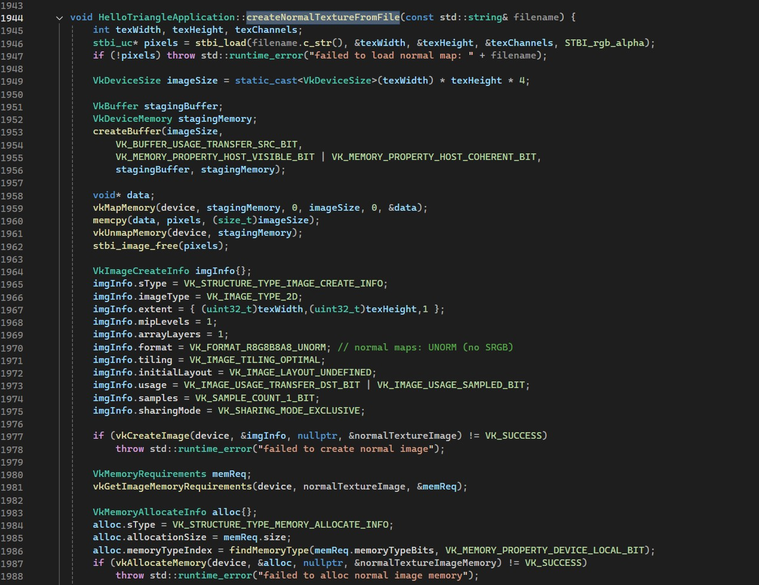

Exercise 3: HEIGHT MAP BUMPY EFFECT
Question: Improve visual quality by moving the lighting logic to the fragment shader, allowing for smoother, more accurate calculations.

Solution: I implemented an alternative bump effect that generates normals on-the-fly from a grayscale height map instead of using a pre-calculated normal map.
In the C++ code, I added the logic to load a new texture ("rockheight.png") and create the corresponding VkImage, VkImageView, and VkSampler for it, as seen in the createHeightTextureFromFile screenshots. I then updated the descriptor set layout and descriptor pool to account for this new heightSampler, binding it to slot 2 (as seen in the shader.frag merge conflict screenshot).
The main work was in the fragment shader (shader.frag). I sampled the new heightSampler to get a single grayscale value, h. Using this height, I calculated its screenspace derivatives with float dHx = dFdx(h); and float dHy = dFdy(h);. These derivatives represent the slope of the height map at that fragment. I used these slopes to construct a new normal vector, which was then used in the world-space Phong lighting equations to create the final bumpy look. The final screenshot shows the "wavy" distortion effect this technique produces.
Reflection: This was a fascinating alternative to normal mapping. It's powerful that you can derive 3D surface information from a simple 2D grayscale texture. Using the dFdx and dFdy functions was new to me, and it was interesting to see how these fragment-shaderonly functions can be used to calculate geometric properties. The visual result is noticeably different from normal mapping—it looks more like a true displacement or distortion, as seen in the output. This exercise helped me understand the practical difference between storing explicit normals (normal map) and deriving them from slopes (height map).
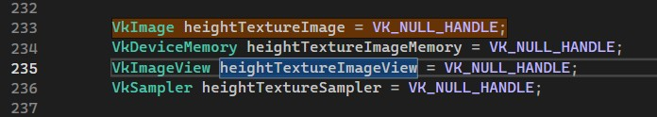
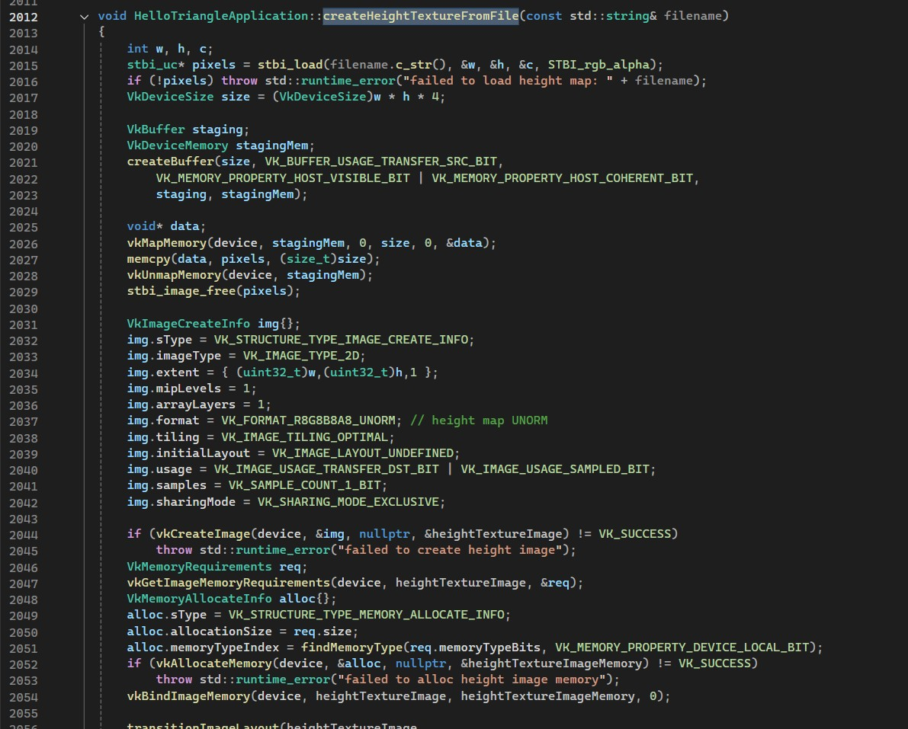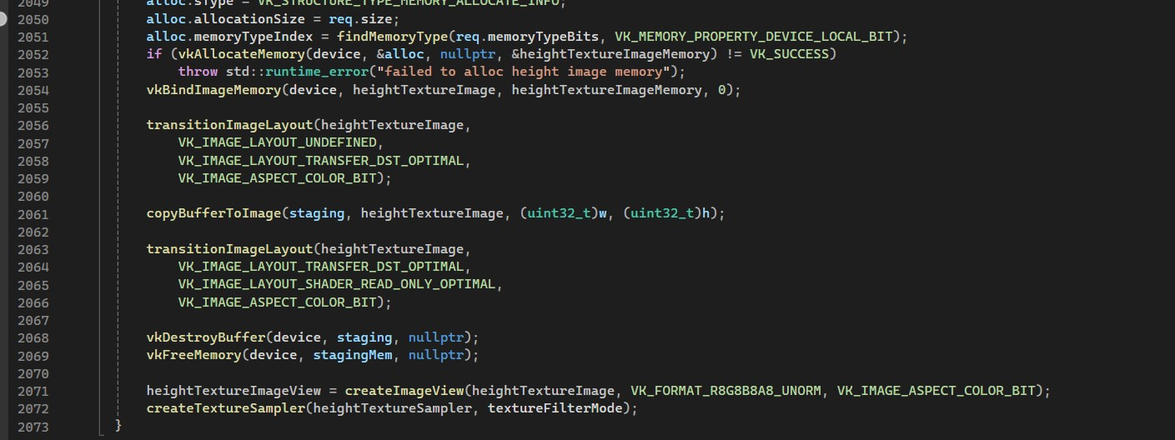
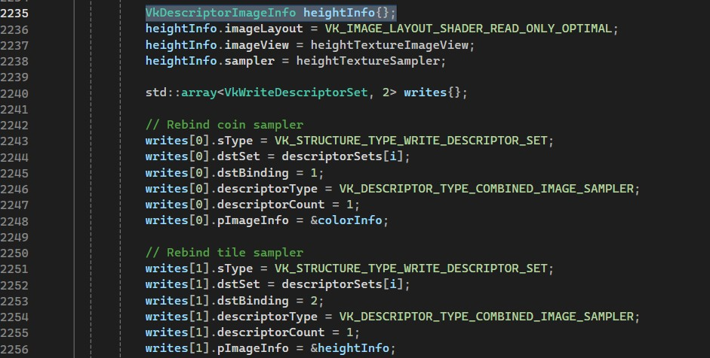

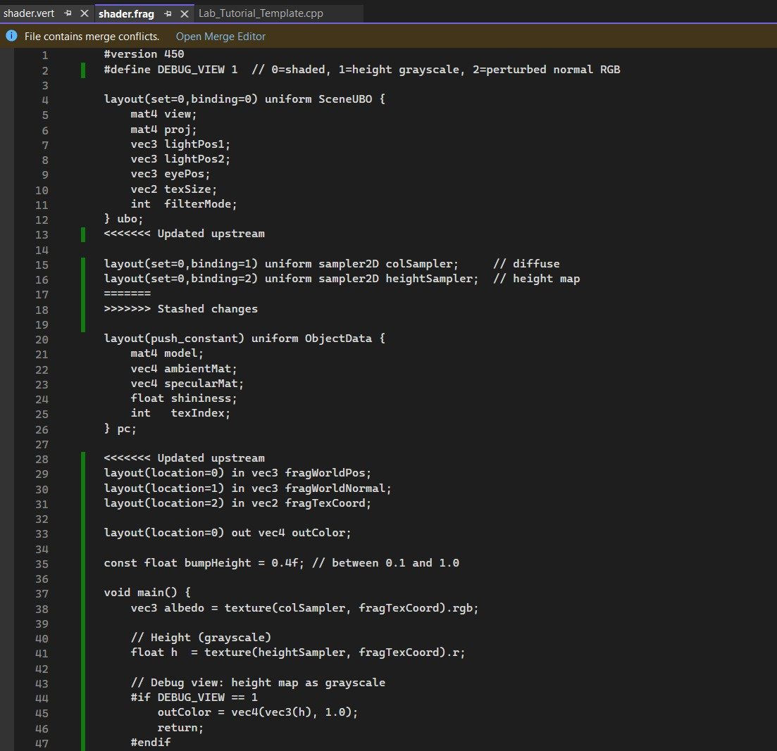
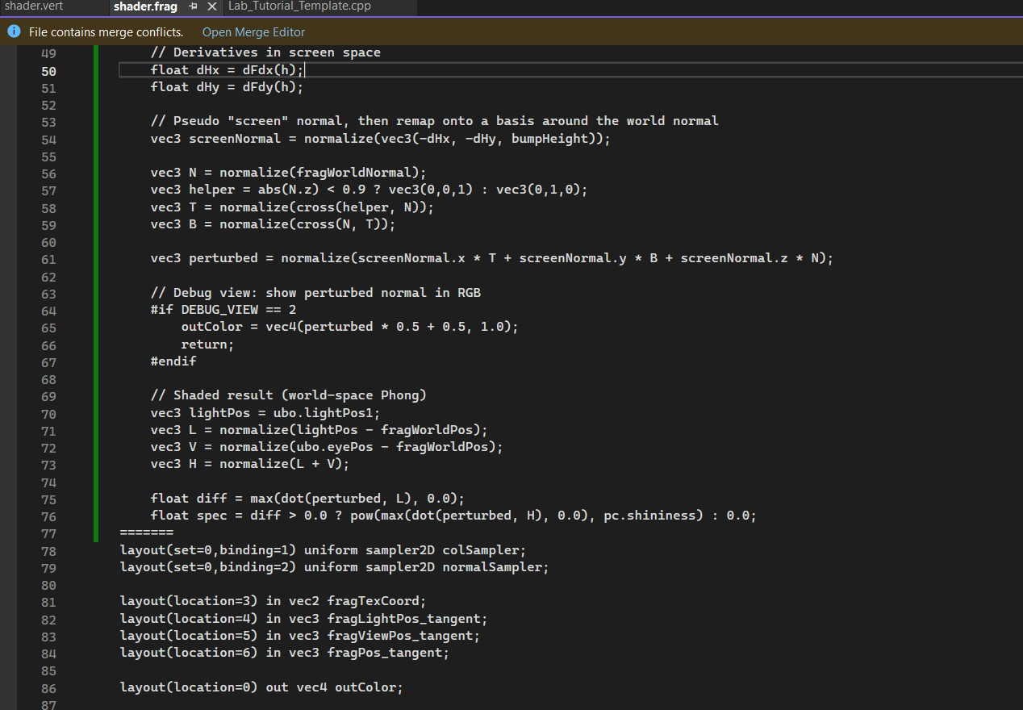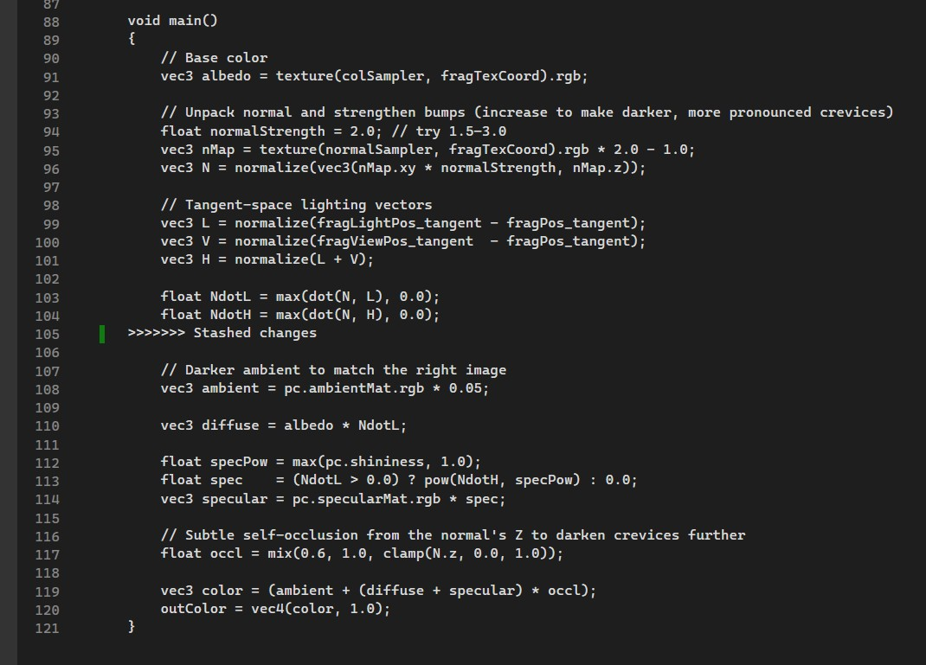

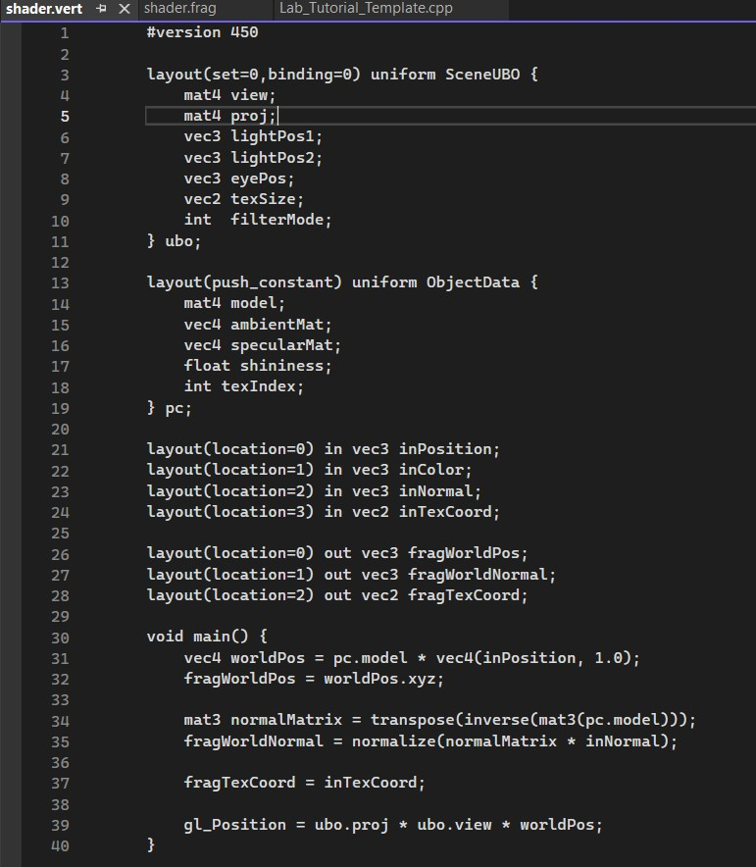

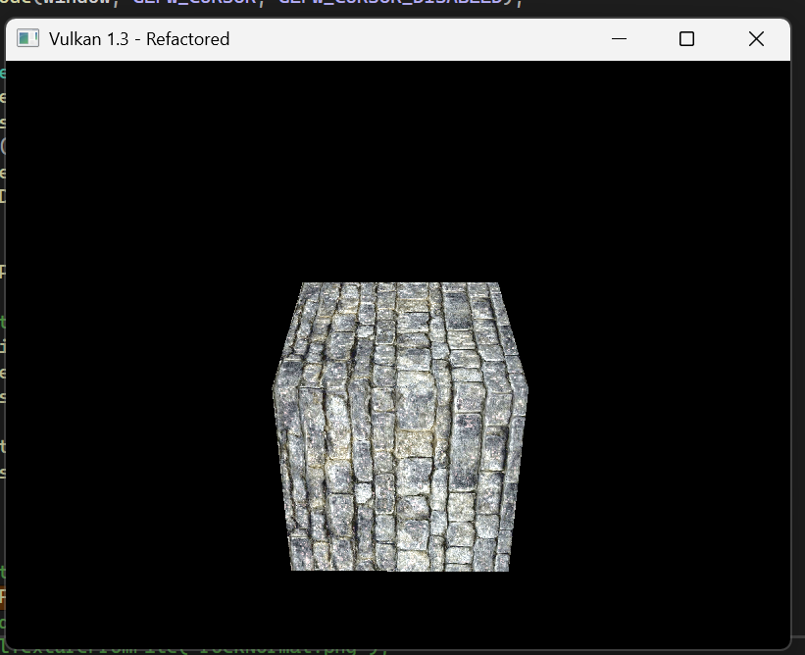

Exercise 4: PROCEDURAL NORMAL MAPPING
Solution: The solution, visible in the shader.frag screenshot, involved two new helper functions. First, a computeTBN function was implemented, which cleverly builds the TBN matrix on-the-fly using screen-space derivatives (dFdx, dFdy) of the fragment's world position and texture coordinates. This advanced technique completely removes the need to pass tangent and binormal vectors from the C++ application.
Second, I wrote a HemisphereBumpTS function. This function mathematically generates a tangent-space normal vector (N_tan) based on the fragment's uv coordinate. It uses fract and dot operations to create a repeating grid of hemispheres.
In the main() function, I first called computeTBN to get the TBN matrix. Then, I called HemisphereBumpTS to get the procedural N_tan. I transformed this procedural normal into world space (vec3 N = normalize(TBN * N_tan);) and used this new N for all world-space Phong lighting calculations, which I also updated to support two light sources. The final screenshot shows the cube rendered with this procedural "rivet" pattern, with each bump correctly catching specular highlights from both lights.

Reflection: This was the most complex but also the most rewarding exercise. Calculating the TBN matrix in the fragment shader using derivatives is a powerful optimization that simplifies the vertex data pipeline significantly. Writing the HemisphereBumpTS function was a great look into procedural generation, showing how simple math can create complex, tileable geometric patterns from scratch.

Question: The computeTBN function in my shader (Image 24) uses dFdx/dFdy on fragWorldPos and fragTexCoord. This seems very efficient. Are there any visual quality downsides or artifacts to this on-the-fly TBN generation compared to using pre-calculated per-vertex tangents, especially on models with sharp UV seams or non-uniform UV scaling?

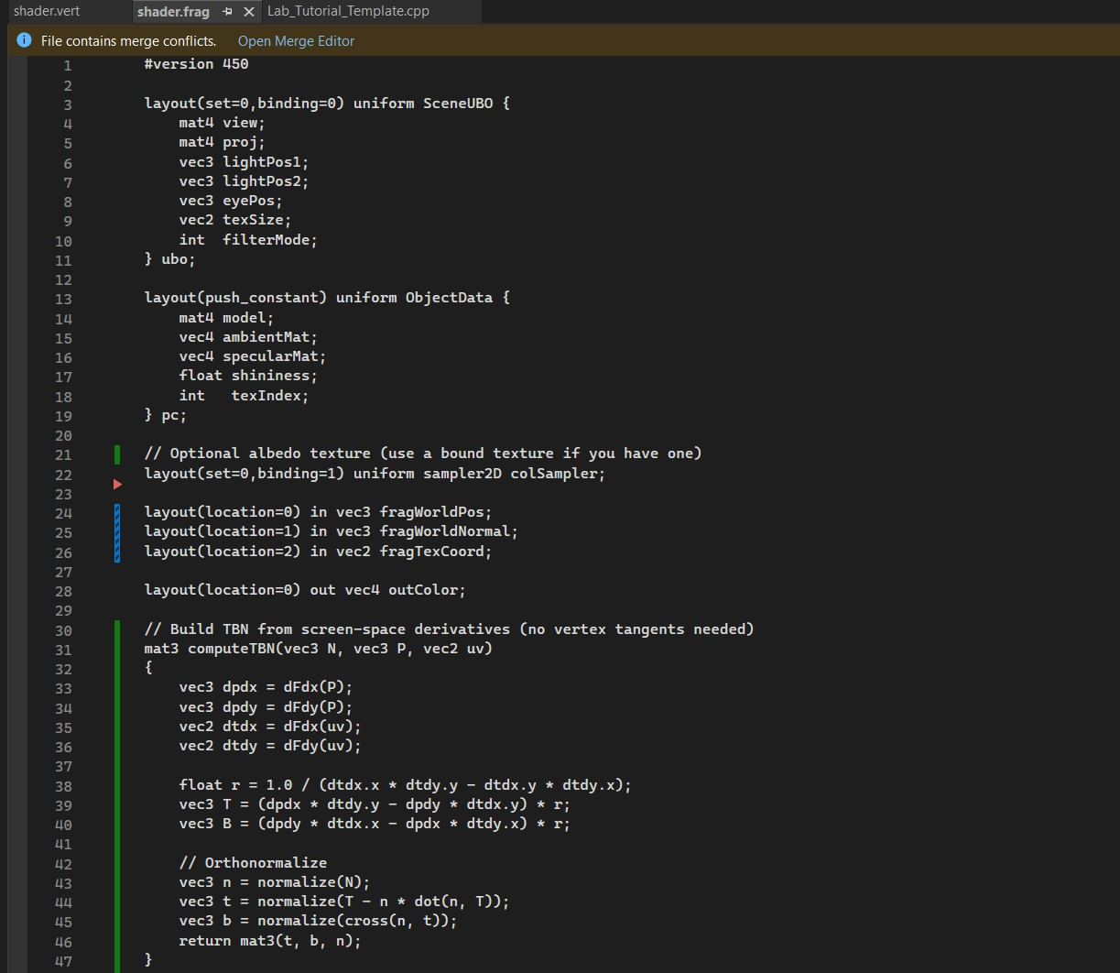
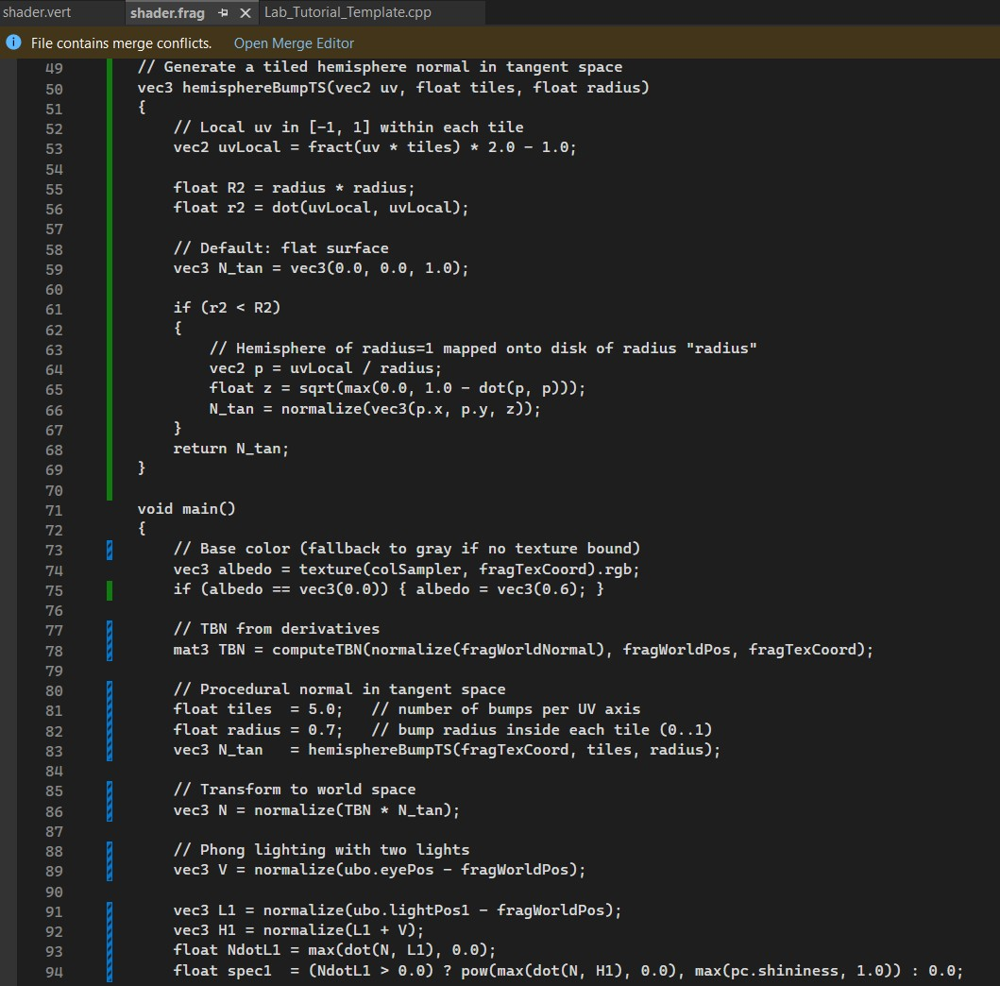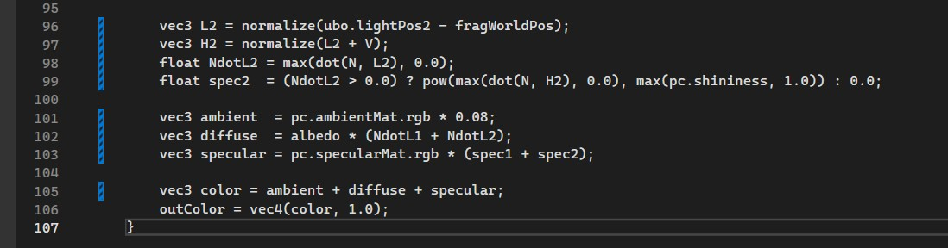
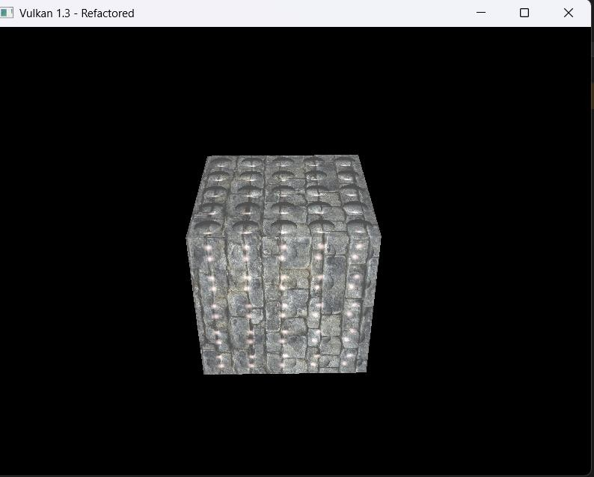

Exercise 5: TEXTURE WRAPPING MODE

Solution & Reflection: I extended the Vulkan rendering pipeline to support binding multiple textures simultaneously, which is the C++-side preparation needed for advanced techniques like parallax mapping.
To prepare for sampling from color, normal, and height maps in a single shader, I had to update the descriptor set configuration.
Layout: In createDescriptorSetLayout (Image 31), I added three separate
VkDescriptorSetLayoutBinding entries for combined image samplers: colorBinding (binding=1), normalBinding (binding=2), and heightBinding (binding=3).
Pool: In createDescriptorPool (Image 28), I updated the VkDescriptorPoolSize for
VK_DESCRIPTOR_TYPE_COMBINED_IMAGE_SAMPLER to allocate
MAX_FRAMES_IN_FLIGHT * 3, ensuring the pool has enough space for all three textures per frame.
Sets: In createDescriptorSets (Image 30) and updateDescriptorSetsSampler (Image 29), I created and wrote three distinct VkDescriptorImageInfo structures (colorInfo, normalInfo, heightInfo) to each descriptor set, binding the correct texture view and sampler to their corresponding slots (1, 2, and 3

Reflection: This task was a great exercise in scaling up the application's resource management. It solidified my understanding of how descriptor sets act as a "bundle" of resources for a shader pipeline. Adding multiple textures was a straightforward process of carefully updating the layout, pool, and set-writing functions. This setup is far more flexible and is clearly the foundation for any modern material system that might use PBR textures (albedo, normal, metallic, roughness, AO) or, in this case, parallax mapping.

Question: I've now set up the C++ side to bind the color, normal, and height maps needed for parallax mapping. The lab describes this technique as displacing UVs based on the view angle and height map. This sounds computationally expensive. Is parallax mapping (or more advanced versions like steep parallax or relief mapping) still a common technique in AAA games, or have modern engines largely replaced it with geometry-based solutions like tessellation and displacement shaders?
